Using Orcad PCB Editor :

1. Generating Reports :

tools ->reports

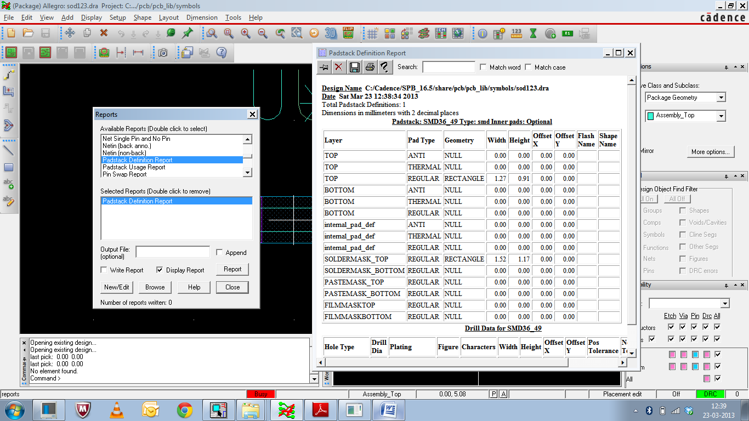

Using Orcad Capture :

1. Right click on the component and select "show footprint"

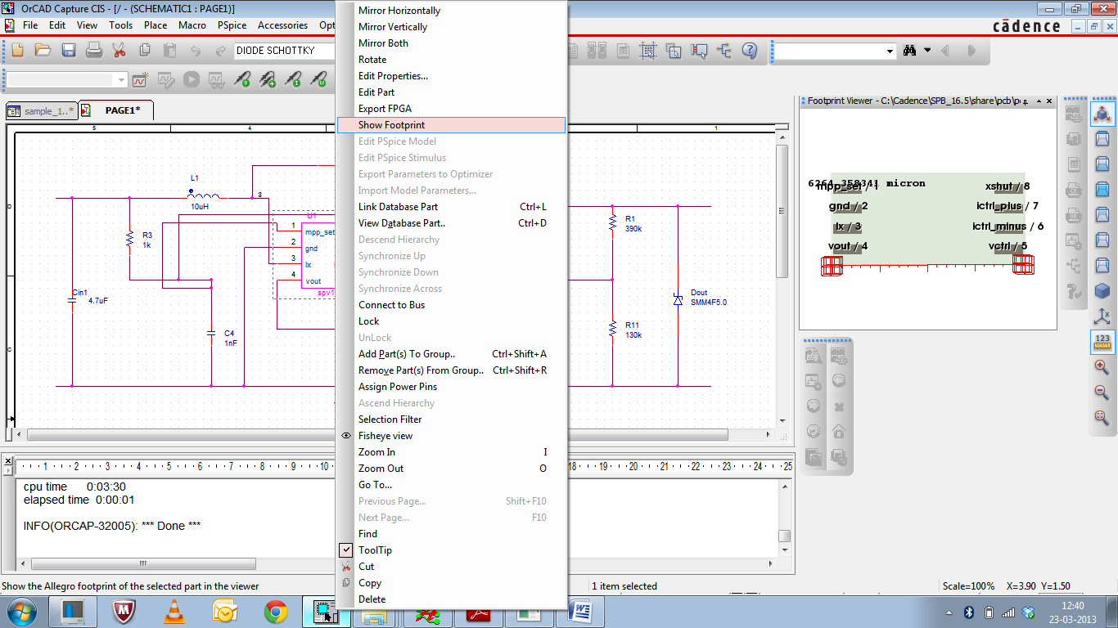

2. select the measure on the right hand side

